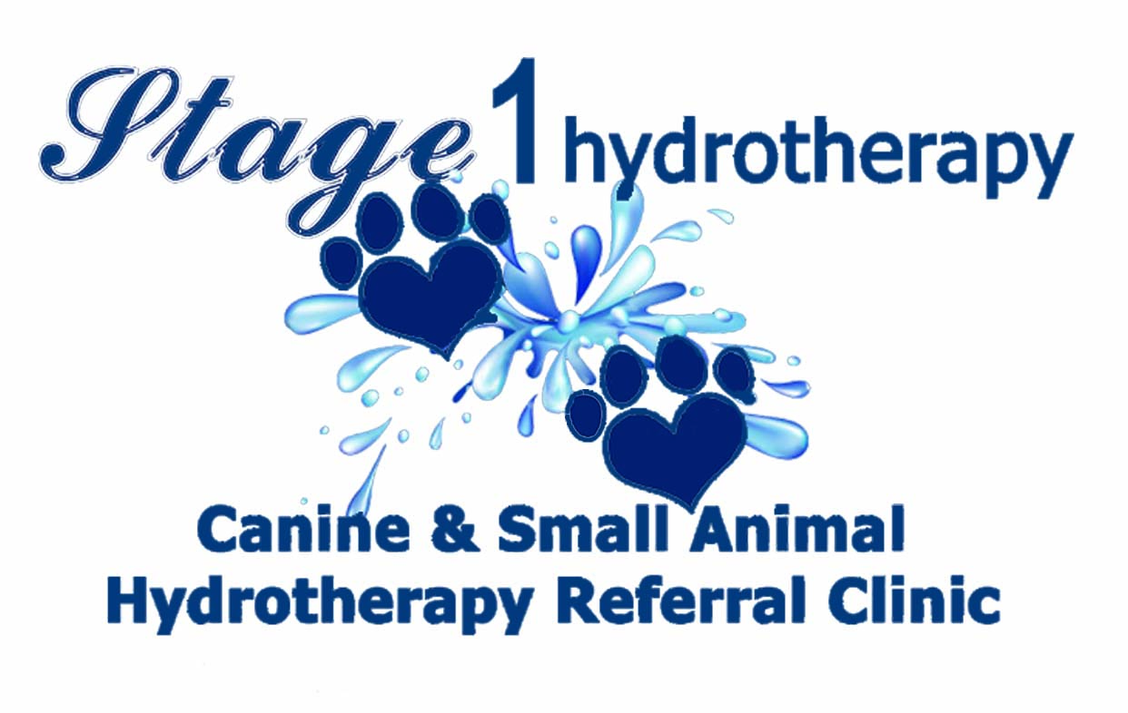
Battery Mill Farm, St Erth, TR27 6JU - hello@stage1hydrotherapy.org.uk - 078611 49503

VETERINARY REFERRAL FORM
Please complete and return to us as soon as possible.

 | Owners Details

Name

Address

Tel No

Email
 | Animal Details
Name |  | Sex |  | Insured | Y/N
Breed/Species |  | D.O.B. |  | Insurance Co.
Colour |  | Vaccination Expiry |  | Policy No
 | Veterinary Practice - Your vet must complete this section.
Referring Vet
Practice
Address
Tel/Fax No
Summary of the animal’s injury/condition, areas of caution, any comments.
Please send case history to admin@stage1hydrotherapy.org.uk if possible. Thank you

Current medication if applicable.
In your opinion, is the animal named above, in a suitable state of health to undergo
Hydrotherapy Treatment Y/N
K-Laser Treatment Y/N
Massage Treatment Y/N

In accordance with the veterinary surgery (Exemptions) order 1962. I give veterinary consent for Stage1hydrotherapy to treat this animal.

Vet’s Signature……………….………………………………………………………………………………………………Date……………
Feedback Report to be sent to; Email:…………………………………………………………………………………………………..

